**Why we are using Bundler ?**  
- A bundler is a tool used in web development that processes the source files of an application into static assets utilised by browsers. The primary purpose of bundlers is to organise modules and dependencies in front-end projects, optimise website performance, and reduce file sizes.  
  
**What are the famous Bundler in market ?**  
- webpack  
- vite   
- parcel   
  
**What is NPM**  
npm` is the world's largest Software Registry. The registry contains over 800,000 code packages. Open-source developers use `npm` to share software.  
- `npm` is the package manager for Node.js. It was created in 2009 as an open source project to help JavaScript developers easily share packaged modules of code.  
  
**What is package.json file**   
The package. json file is the heart of any Node project. It records important metadata about a project which is required before publishing to NPM, and also defines functional attributes of a project that npm uses to install dependencies, run scripts, and identify the entry point to our package.  
  
**What is the use of package-lock.json file**   
The package-lock. json file is an automatically generated file in Node. js projects, created when you first run npm install. Its primary role is to lock down the exact versions of every package and its dependencies that are installed in your project  
  
**What is Component in React JS**   
React component is a reusable piece of code responsible for rendering a part of the user interface. These components can be as simple as a button or as complex as an entire form. The modular nature of React components allows developers to break down their applications into manageable and reusable chunks, fostering a clean and organized codebase.  
  
Ex  
  
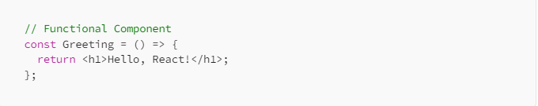

**What is JSX**  
JSX is a syntax extension for JavaScript that lets you write HTML-like markup inside a JavaScript file. Although there are other ways to write components, most React developers prefer the conciseness of JSX, and most codebases use it.  
  
**How to write an Expression in React JS**We can write an expression inside jsx using curly bracket   
  
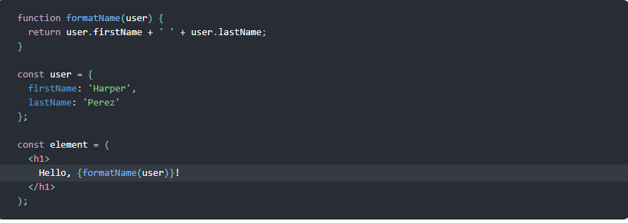

**What is the use of Key property in React JS**   
A “key” is a special string attribute you need to include when creating lists of elements in React. Keys are used in React to identify which items in the list are changed, updated, or deleted. Keys are used to give an identity to the elements in the lists  
  
**What is Children props** .  
props.children in React. props.children is a powerful feature that allows you to create flexible, reusable components that can be customized with any content you want. Whether you’re passing in simple HTML elements or complex React components, props.children gives you the flexibility to create components that can be used in many different parts of your application.

Ex of children prop  
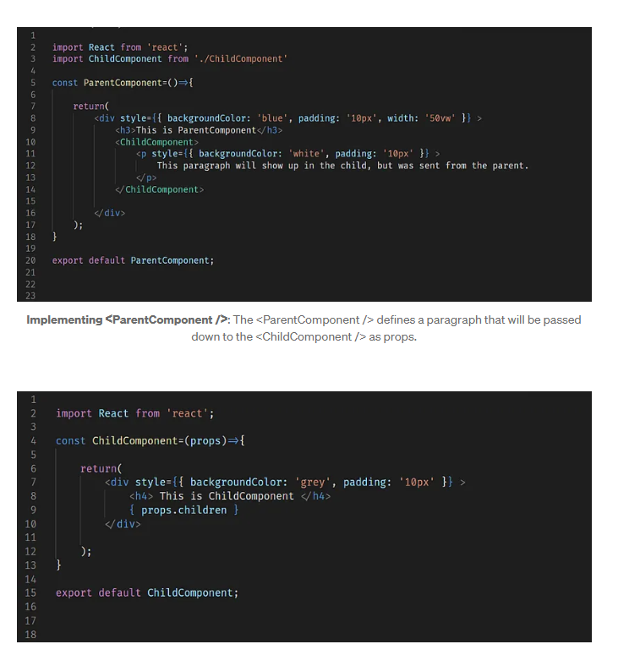  
  
**What is props in functional component ?**Props is a special keyword in React that stands for properties and is used for passing data from one component to another. Data with props are passed in a unidirectional flow from parent to child.  
  
**How to give styling to JSX**  
To apply inline styles in JSX, you simply pass the style object to the **style** attribute of a JSX element. Here’s an example:  
  
